Appendix A: Figures

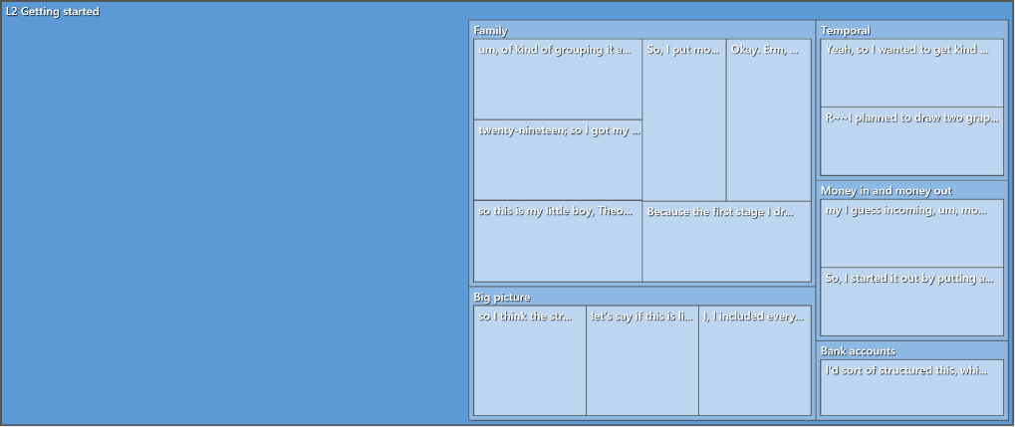

Figure A1: The node hierarchy chart for getting started

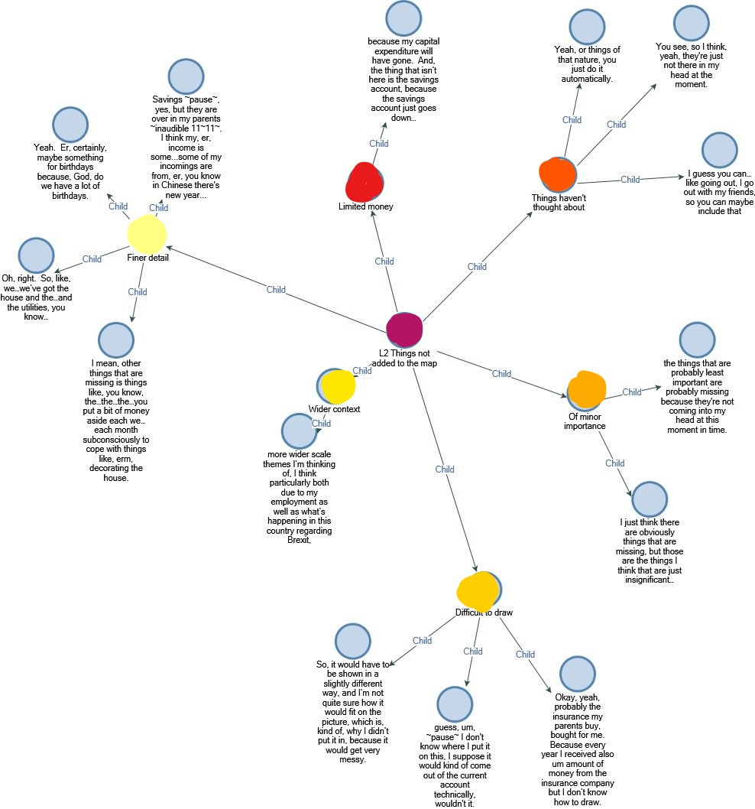

Figure A2: Full “Things not added to the map” node map.

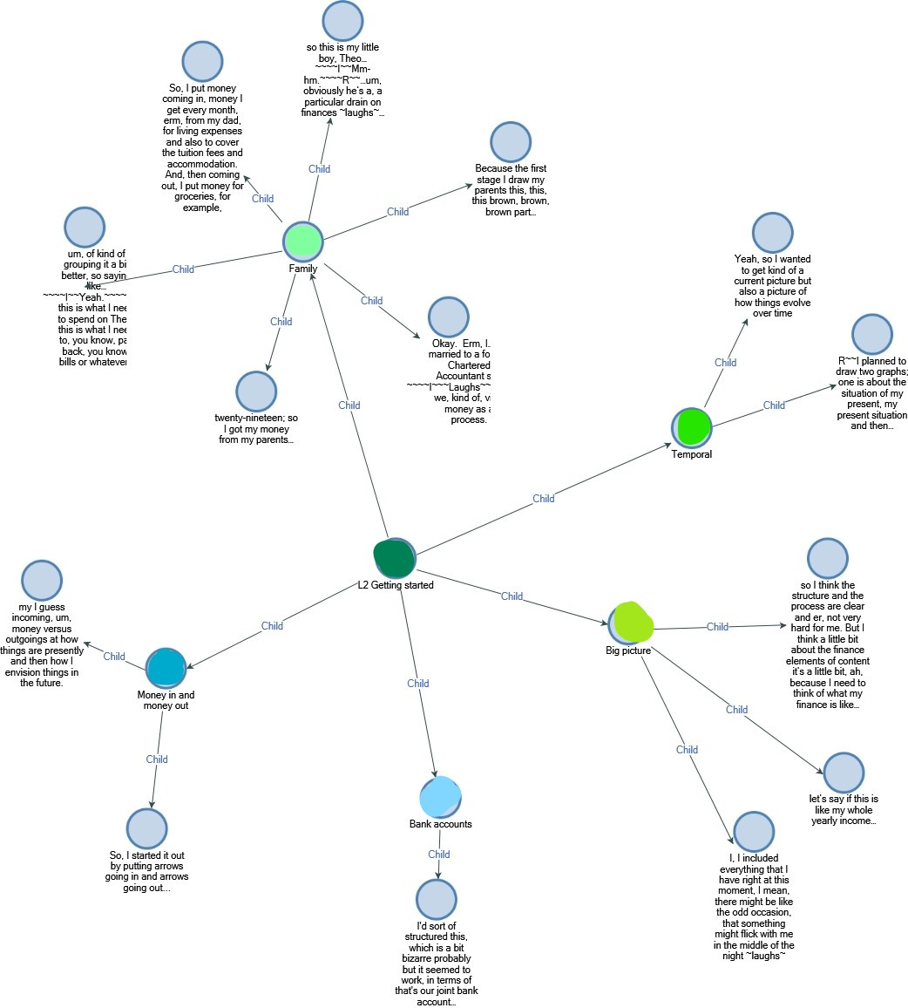

Figure A3: The full “getting started” node map

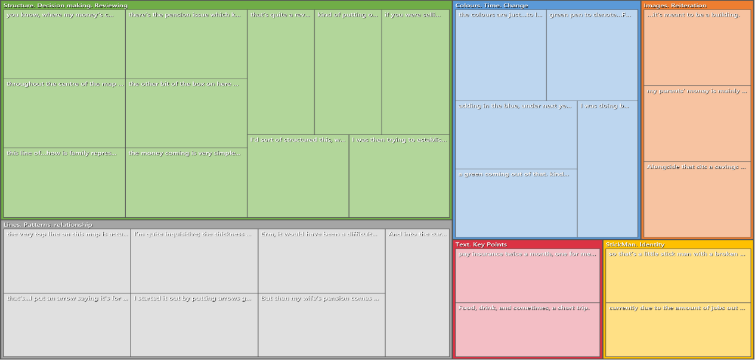

Figure A4: Node hierarchy chart for “Image site” codes

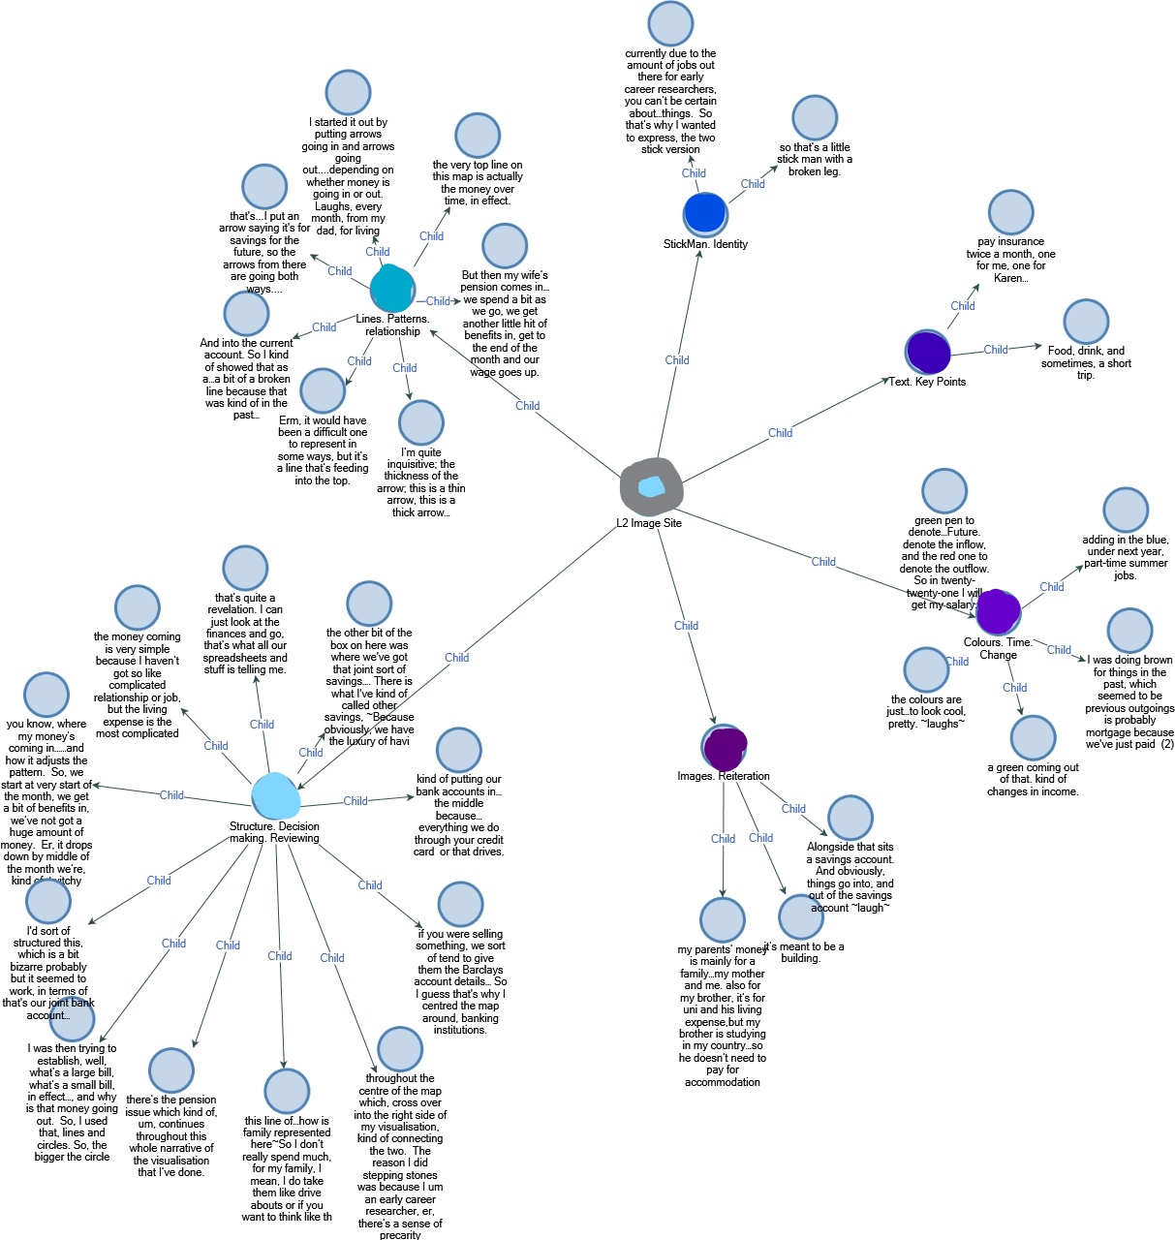

FigureA 5: Full Image site node map

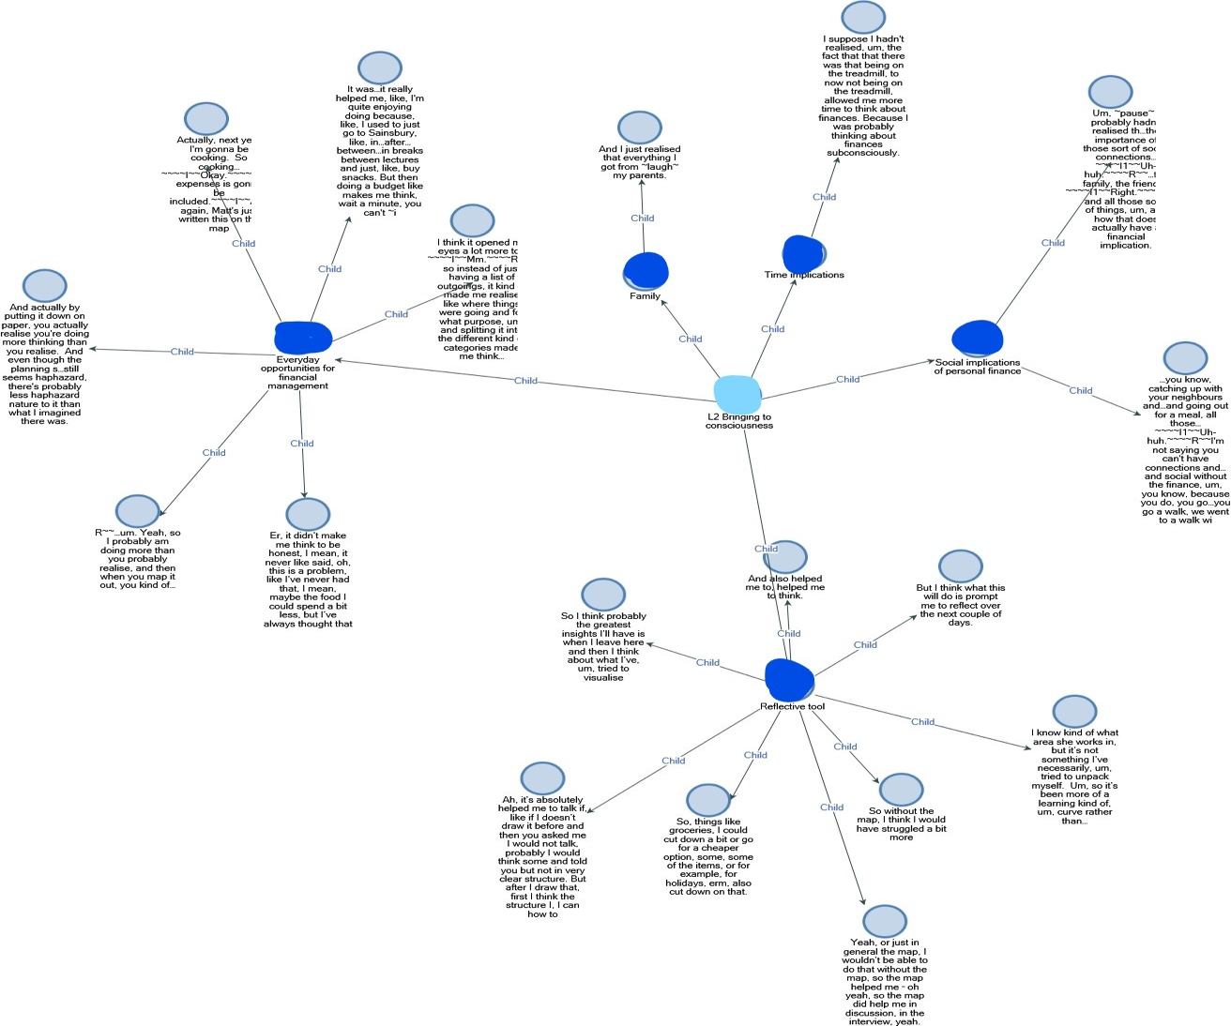

Figure A6: Full “Bringing to Consciousness” node map.

Appendix B: Table

|  |  |  |
| --- | --- | --- |
| Participant | Quotes | Subjectivities or financial identities |
| P1 | In terms of outgoings, I’ve been thinking about buying my own place, and then obviously the situation that I described before about, you know, kind of accommodation and bills all in one fixed lump sum, um, it would be separated in terms of different bills, so that’s why they’ve been, um, separated. Equally I’m not sure I want to stay in the UK, so there’s an element of travel, but also foreign kind of, um… | A desire in this case to be a homeowner in the future. |
| P2 | Because fortunately I’ve got a…a husband income… | ‘Husband income’, an interesting term, really connects the income and the husband as an helpful appendage. |
| P3 | But, I’d like to ...run my own business one day, so thats a bit of money that would help. | ‘A future business owner’ so an identity as a future business owner connected with their savings. |
| P4 | I do have a savings account, but I don’t use it, so I don’t really have one. So, it’s all staying in my normal current account, um. Because I don’t…with me, er, personally I don’t spend my money, er, I control it quite well, so if I don’t need anything, I won’t buy it, unlike some people that would buy. | ‘Idea of themselves as someone who can control their spending’ and that is being a good thing, a fundamental good. |
| P5 | I enjoy that, yeah, I enjoyed to manage my, my own money but sometimes find it a little bit hard because um, I don’t want to, I don’t want to spend too much money from, from my parents so we fixed a…a amount of money like they give to me. | Again, here that independence being in question, ‘having money from parents but not wanting to spend it’. |
| P6 | I’m married to a former Chartered Accountant so…we, kind of, view money as a process. | Interesting here the chartered accountant legitimises the process gives status to their view and manage money management. |
| P7 | um, and I think that’s one of the…I suppose that’s one of the issues when you dig down into my reasons, that…I’ve never really developed that self- control with money ‘cause I know that my dad’s always at the bottom when I run out [laughs] kind of thing…which is really bad to admit. | Again ‘self-control’ picked up on and this time the Bank of dad is there to help out, but issues there are worth exploring. |
| P8 | Some drinks, so…so that I wont be like the only one who didn’t, like, get alcohol, because I dont want to be like appearing as a cheapskate. | The idea of being ‘a cheapskate’, a negative identity, if they dont buy their own share of alcohol. |
| P9 | Through this exercise I make up my mind to pay for my wife through my lifetime. Ok it’s, it’s an important. err, financial decision. And not only a financial decision but also a love decision, I think. [laughs] | An imagined future with a future wife, where they take control where they take financial responsibility. |
| P10 | I dont want to depend on other people. Why dont you want to depend on other people? Because when I use my own money its like...it feels like I’m free to do anything [laughs] | A feeling of ‘feeling free’ of being independent from other people. ‘Money buys freedom’. |
| P11 | And then… yeah, we need [pause] but before we get married, I mean before I get married I want to have a [pause] a…I have…I want to have a [pause] stable finance, so like maybe bought a house before…before getting married. | Again getting married and financial and middle-class life. |

Table B1: An analysis of students’ revealing subjective or financial identities, as they are talking about their maps.